**THERE IS / THERE ARE**

**Использование –** *для того, чтобы сообщить, что* ***кто-то или что-то*** *есть, существует, находиться или происходит в определенном месте, в определенное время, в определенной ситуации.*

**THERE IS, THERE ARE – USE**

*We use* ***there is, there*** *are to say that something* ***exists****.*

*There is a lot of noise.*

***Where*** *something is*

*We often use* ***there is, there*** *are to say* ***where*** *something is.*

*There is a good restaurant at the end of the street.*

*There are some keys in that box.*

***When*** *something happens*

*We can also use* ***there is, there are*** *to say* ***when*** *something happens.*

*There is a concert tonight.*

*There are a lot of storms in summer.*

**A, SOME, ANY**

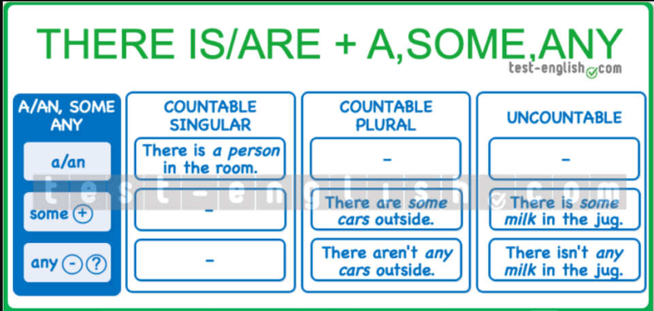*We often use* ***there is, there are*** *+ a, some, any.*

***there is*** *+ singular /* ***there are*** *+ plural*

*We use* ***there is + singular*** *noun, and* ***there are + plural*** *noun.*

*There is a new teacher in the school.*

*There are some problems that we need to solve.*

*We use there is + a list of things if the first noun after ‘****there is’*** *is singular.*

*In the room, there is a bed, a wardrobe and two chairs.*

**THERE IS, THERE ARE – FORM**

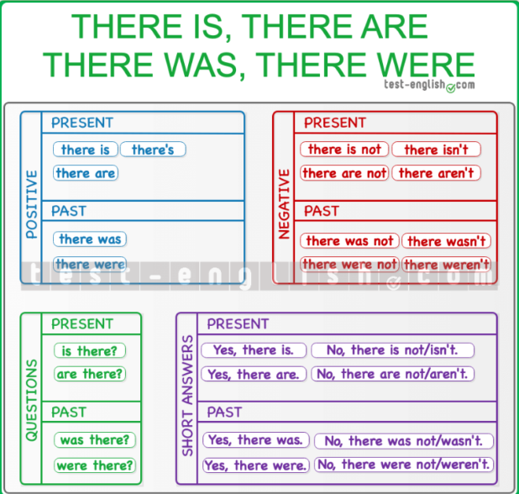

*Present and past*

*The past form of* ***there is, there are*** *is* ***there was, there were****.*

*There is a car in the street. ⇒ There was a car in the street.*

*There are some cars in the street. ⇒ There were some cars in the street.*

*Short forms*

*The short form of* ***there is there’s****, but we don’t use a short form of there are.*

*There’s is not used in short answers.*

*There’s a new secretary in the office.*

*There are two bathrooms in this house.*

***There are no short forms for there was/there were.***

***In negative sentences****, we often use the short forms there isn’t/there aren’t and there wasn’t/weren’t.*

*There isn’t any bread left. We need to buy more.*

*There aren’t any cookies in the jar.*

**THERE OR IT**

**THERE**

*We use there to say* ***when*** *or* ***where******something******is****.*

*There are some dirty cups on the table.*

*There is a party tomorrow.*

*We use there to say that something* ***exists*** *or* ***is happening****.*

*There is a problem.*

*There was an accident.*

***Note*** *that we use there* ***the first time we mention something****. If we talk about* ***the same thing again****, we use* ***it*** *or* ***they****.*

*There are some cups on the table. But they are dirty.*

*There was an accident. It was horrible.*

**IT**

*We use* ***it*** *to talk about* ***something again*** *in the conversation.*

*There is a party tomorrow. It will be fantastic!*

*We saw a snake in the forest. It was very big.*

*We use* ***it*** *to talk about* ***times*** *and* ***dates****.*

*It‘s my mum’s birthday today.*

*Let’s go home. It‘s very late.*

*It‘s four o’clock.*

*We use* ***it*** *to talk about* ***the******weather****.*

*It‘s very windy.*

*It‘s a nice day.*

*It rained a lot yesterday.*

*It‘s four degrees.*

*We use* ***it*** *to talk about* ***distance****.*

*How far is it?*

*It‘s not very far.*

*It‘s a long way to the nearest petrol station.*

*It‘s 2 kilometers from the hotel to the station.*

***Note*** *that we use* ***far*** *in* ***negative******sentences*** *and* ***questions****, and we use* ***a long way*** *in* ***affirmative******sentences****. We use* ***far*** *in* ***questions*** *(is it far?) and* ***negatives*** *(it isn’t far). In* ***positive*** *sentences, we use* ***a******long way*** *(it’s a long way).*

***We use*** ***it’s + adjective + to + infinitive.***

*It’s nice to see you again.*

*It was difficult to find the hotel.*

**BE CAREFUL WITH THESE COMMON MISTAKES!**

*I think the worst part of the exam ~~it’s~~ speaking.*

*I think the worst part of the exam is speaking.*

*We do NOT use* ***it*** *when the subject of the verb is in the sentence. In the sentence above, the subject of* ***is*** *is ‘the worst part of the exam’.*

*I love their music. ~~Is~~ fantastic!*

*I love their music. It’s fantastic!*

*Don’t forget to use* ***it*** *when you* ***mention something again in the conversation****.*